EXCEL REVIEW ACTIVITY “Amusement Parks!”
It’s your birthday and your parents have given you the choice of going to any one of five amusement parks in California. There is just one catch – they have asked that you choose the park with an entrance fee that is cheaper. Surf the internet to find how much it will cost for YOUR family to go to each park. Put your information into a spreadsheet and then graph your findings.

Amusement Park Choices (For prices Google the park + ticket prices)

- Disneyland
- Knott’s Berry Farm
- Six Flags – Magic Mountain
- Universal Studios
- Sea World San Diego

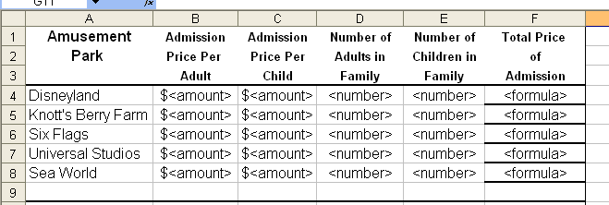
- Go to each of the five amusement park websites. Compute how much it will cost for your family to enter only THAT park for just ONE day. After gathering all of the information, put your findings into a well-organized spreadsheet. An example of one way to set up the data is below:


2. HINT: The formula for total price of admission would include the admission price per adult times the number of adults in your family PLUS the admission price per child times the number of children in your family.

3. Before you go any further, be sure you go to File-Page Set-up and format for landscape mode, add a footer with your name and grade.
5. Now you will GRAPH your findings. Highlight the entire columns B through E and right click

6. Decide which graphing process will give you the best analysis or show the information the easiest: column, bar, or line. Label the graph appropriately with a title, x and y axis. You may want to add the dollar amounts (value) to data labels.

7. When your chart is complete, hit print preview to check you are still on one page, then save

