
Nivel Secundaria
Quinto Curso Sección A, B
Tecnología
Mónica Herrera

EXAMEN IV BIMESTRE

Nombre: Fecha:

- Open adobe illustrator
- Go to archive Name it Final exam name and grade
- Page size letter, layout of the page horizontal
- Draw an image that represent children´s day
The drawing should include the following
  - Shapes
  - An image draw by you using the pluma or pencil tool
  - A few images from the internet
- Include a phrase that tells What´s your best memory from when you were a child. Font style Snap ITC, size 20, color green
- When you finish drawing you need to color it. Use the gradient tool to color the shapes that you use.
- With the dropper tool o herramienta cuentagotas se puede colorear del mismo color que el original (if you have an original drawing)
- Save it as pdf
- Export it as Png and send both documents to me mherrera@agustiniano.edu.gt
Example:
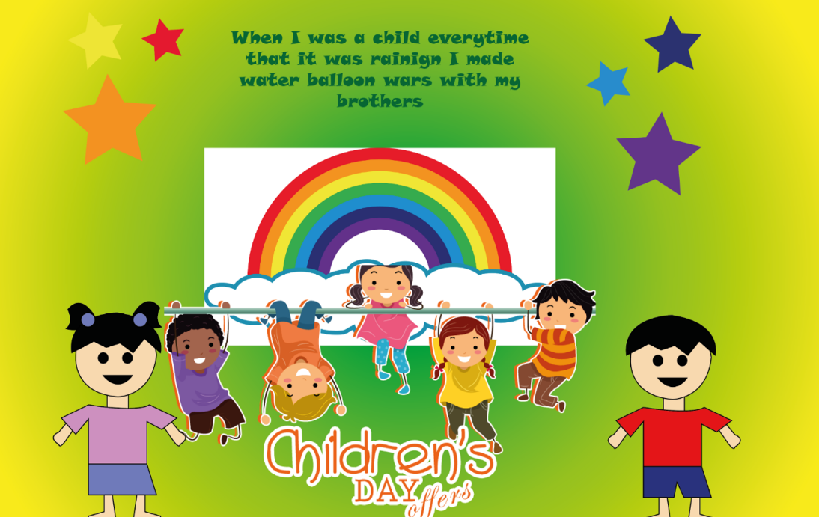

Check the list so you don´t miss anything.
Check list to grade illustrator

Name it correctly | 10 pts.
Size and layout | 10 pts.
Drawing (include shapes, own drawing and images) | 30 pts.
Use the gradient tool, pen tool etc. | 10 pts.
Phrase and use of text tool | 10 pts.
Save it as pdf | 10 pts.
Save it as png | 10 pts.
Send it to my email | 10 pts.
Final grade | 100 pts.

